**Student name:** Tran Thien Phuc – SE130139

**Entity Relational Diagram**

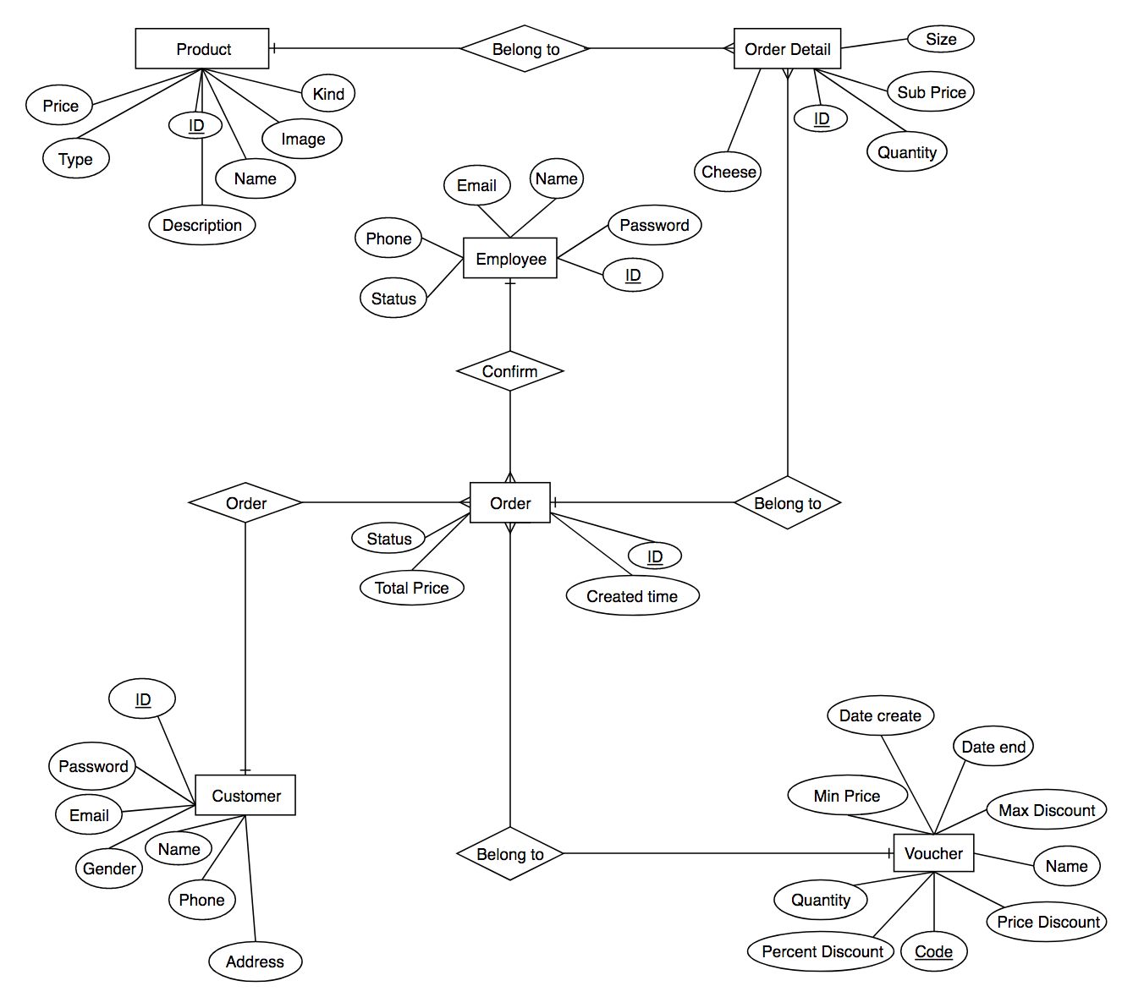

DOMINO PIZZA (http:// dominos.vn)